Chapter 5 - Foundations for Inference

**Heights of adults.** (7.7, p. 260) Researchers studying anthropometry collected body girth measurements and skeletal diameter measurements, as well as age, weight, height and gender, for 507 physically active individuals. The histogram below shows the sample distribution of heights in centimeters.

100

80

60

40

20

0

150 160 170 180 190 200

# Height

1. What is the point estimate for the average height of active individuals? What about the median?
2. What is the point estimate for the standard deviation of the heights of active individuals? What about the IQR?
3. Is a person who is 1m 80cm (180 cm) tall considered unusually tall? And is a person who is 1m 55cm (155cm) considered unusually short? Explain your reasoning.
4. The researchers take another random sample of physically active individuals. Would you expect the mean and the standard deviation of this new sample to be the ones given above? Explain your reasoning.
5. The sample means obtained are point estimates for the mean height of all active individuals, if the sample of individuals is equivalent to a simple random sample. What measure do we use to quantify the variability of such an estimate (Hint: recall that *SDx* = *√σ* )? Compute this quantity using the data from the original sample under the condition that the data are a simple random sample.

*n*

**ANSWER**

**A.** From the histogram above, the point estimate for the **average height** (mean) of active individuals seems to be around the center of the distribution, which looks to be approximately **171 cm** (based on visual inspection).

As for the **median**, it’s the value that splits the data in half. Based on the shape of the histogram, the median height also appears to be around **171 cm**, close to the mean since the distribution seems symmetric.

**B.** We can provide rough visual estimates for the **standard deviation** and **interquartile range (IQR)** of the heights of active individuals.

**Standard Deviation (σ):**

* The standard deviation is a measure of how spread out the values are from the mean.
* From visual inspection, the distribution seems symmetric, and the data appears to span roughly between **162 cm and 180 cm**, with the centre around **171 cm**.
* A rough estimate for the standard deviation would be about **5 to 6 cm**, given that most data points seem to cluster within one or two standard deviations of the mean.

**Interquartile Range (IQR):**

* The IQR is the range between the first quartile (Q1, 25th percentile) and the third quartile (Q3, 75th percentile).
* From the histogram, Q1 might be around **166 cm**, and Q3 around **176 cm**.
* Therefore, the IQR appears to be approximately **10 cm** (176 cm - 166 cm).

These are rough estimates based on the visual inspection of the histogram, and more precise calculations would require the actual data points or frequency distribution.

**C.** Now for determining if a person who is 180 cm (1.8m) tall or 155 cm (1.55m) short is considered unusual, we need to evaluate how far these values are from the mean height, based on the histogram, and compare them to the estimated standard deviation.

**Mean and Standard Deviation:**

* Based on the previous estimates, the **mean height** is approximately **171 cm**.
* The **standard deviation** was roughly estimated at around **5 to 6 cm**.

**Unusually Tall (180 cm):**

* 180 cm is **9 cm above** the mean (180 cm - 171 cm = 9 cm).
* As from visual inspection we have got the standard deviation of 5 to 6 cm, this places a height of 180 cm around **1.5 standard deviations** above the mean.
* Heights that are more than **2 standard deviations** away from the mean are often considered unusual, so a height of 180 cm would not be considered unusually tall.

**Unusually Short (155 cm):**

* 155 cm is **16 cm below** the mean (171 cm - 155 cm = 16 cm).
* This places a height of 155 cm at about **2.7 to 3 standard deviations** below the mean, assuming the standard deviation is 5 to 6 cm.
* Since this is more than 2 standard deviations away from the mean, a person who is 155 cm tall could be considered **unusually short**.

**Conclusion:**

* A height of 180 cm is **not unusually tall**.
* A height of 155 cm is **unusually short**, based on its distance from the mean.

**D.** No, we wouldn't expect the mean and standard deviation of the new sample to be exactly the same as the ones given above, but we would expect them to be **similar**. Here’s why:

**1. Sampling Variation:**

* Each sample drawn from a population will exhibit some degree of natural variation. For instance, one sample may consist of individuals with slightly different heights, resulting in a slightly different mean and standard deviation.
* While the mean and standard deviation may fluctuate based on the makeup of each sample, they should remain close to previous estimates if the sample is large and randomly selected.

**2. Large Numbers:**

* As the sample size grows, the sample mean becomes closer to the true population mean. Therefore, with a large enough sample size, the new sample's mean is expected to be similar to the previous sample’s mean of 171 cm.

**3. Random Sampling:**

* If a new sample is drawn randomly from the same population of active individuals, we should expect the distribution of heights to closely resemble that of the original sample. As a result, the variability in heights, represented by the standard deviation, should remain near the earlier estimate of 5 to 6 cm.

**E. Formula for Standard Error (SE):**

The standard error is calculated as:

SE = σ/sqrt{N}

Where:

* σ is the population standard deviation (or the sample standard deviation if the population value is unknown).
* N is the sample size.

**Step-by-Step Calculation:**

1. **Estimate Standard Deviation (σ):** Based on previous estimates, the standard deviation (σ) of the heights of active individuals was approximately **5 to 6 cm**.
2. **Sample Size (n):** Sample size from the original data which is 507. It needs to be provided to compute SE.
3. **Compute SE:** Using the estimated standard deviation of 6 cm (taking the higher end for a more conservative estimate) and a size of 507:

SE = 6/sqrt(507) = 0.26646

This means that the variability of the sample mean is **0.26 cm**.

**Thanksgiving spending, Part I.** The 2009 holiday retail season, which kicked off on November 27, 2009 (the day after Thanksgiving), had been marked by somewhat lower self-reported consumer spending than was seen during the comparable period in 2008. To get an estimate of consumer spending, 436 randomly sampled American adults were surveyed. Daily consumer spending for the six-day period after Thanksgiving, spanning the Black Friday weekend and Cyber Monday, averaged $84.71. A 95% confidence interval based on this sample is ($80.31, $89.11). Determine whether the following statements are true or false, and explain your reasoning.

80

60

40

20

0

0 50 100 150 200 250 300

# Spending

1. We are 95% confident that the average spending of these 436 American adults is between $80.31 and

$89.11.

1. This confidence interval is not valid since the distribution of spending in the sample is right skewed.
2. 95% of random samples have a sample mean between $80.31 and $89.11.
3. We are 95% confident that the average spending of all American adults is between $80.31 and $89.11.
4. A 90% confidence interval would be narrower than the 95% confidence interval since we don’t need to be as sure about our estimate.
5. In order to decrease the margin of error of a 95% confidence interval to a third of what it is now, we would need to use a sample 3 times larger.
6. The margin of error is 4.4.

**ANSWER**

1. FALSE - The point estimate does not necessarily fall within the confidence interval every time.
2. FALSE - The data is right-skewed, but the skewness is not very pronounced.
3. FALSE - The average expenditure of all American adults is being approximated using a point estimate and a confidence interval.
4. TRUE - A 90% confidence interval does not require a wide range to include the values, resulting in a narrower interval.
5. TRUE - A 90% confidence interval would be narrower since it doesn't need to encompass a broader range of values. This means we can be 90% confident that our point estimate encompasses the true population value.
6. FALSE. To reduce the margin of error to one-third of its current value, we need to increase the sample size to nine times the current amount.
7. TRUE. The margin of error can be expressed as half the difference between the upper and lower bounds, which in this case is calculated as (89.11 - 80.31) / 2 = 4.4. In simpler terms, the margin of error represents the range within which we expect the true value to lie, and here it is 4.4.

**Gifted children, Part I.** Researchers investigating characteristics of gifted children col- lected data from schools in a large city on a random sample of thirty-six children who were identified as gifted children soon after they reached the age of four. The following histogram shows the dis- tribution of the ages (in months) at which these children first counted to 10 successfully. Also provided are some sample statistics.

6

3

0

20 25 30 35 40

# Age child first counted to 10 (in months)

n min mean

sd max

36

21

30.69

4.31

39

1. Are conditions for inference satisfied?
2. Suppose you read online that children first count to 10 successfully when they are 32 months old, on average. Perform a hypothesis test to evaluate if these data provide convincing evidence that the average age at which gifted children fist count to 10 successfully is less than the general average of 32 months. Use a significance level of 0.10.
3. Interpret the p-value in context of the hypothesis test and the data.
4. Calculate a 90% confidence interval for the average age at which gifted children first count to 10 successfully.
5. Do your results from the hypothesis test and the confidence interval agree? Explain.

**ANSWER**

1. Yes. A random, large sample with no skewness. Since the sample size is over 30, the data roughly follows a normal distribution, there are no visible outliers in the histogram, and the sample was gathered from schools in a large city.
2. N = 32 months  
   t-critical value for a one-tailed test at α = 0.10 is -1.69  
   Degrees of freedom is: df=n−1=36−1=35, Where n=36 is the sample size.

 t = (30.69 - 32)/(4.31/sqrt(36)) = -1.824.

We will reject the null if t < -1.69 or t > 1.69  
  
The calculated t-value is -1.824, and since it is less than the critical value of -1.69, we reject the null hypothesis. This indicates that, at the 0.10 level of significance, we have enough evidence to conclude that the average age at which gifted children first successfully count to 10 is less than 32 months.

1. Calculating the **p-value** in a two-tailed **t-test**.  
   2 ( 1 – P ( t < ( 1.824 ) ) = 2 ( 1 - 0.9616 ) = 0.0767.   
   Since 0.0767 < 0.10;   
   We reject the null hypothesis.  
     
   **FROM CODE**  
   If the null hypothesis holds, the likelihood of getting a sample mean less than 30.69 from a sample of 36 children is just 0.0344 (p-value). In relation to a significance level of 0.1, we are able to reject the null hypothesis.  
     
   A close-up of a text

   Description automatically generated
2. Critical value for 90% Confidence Interval is 1.645  
     
   The 90% confidence interval is:  
   = mean ± margin error = 30.69 ± 1.69*(0.7183) = 30.69 ± 1.21 = (29.5, 31.9).   
   Thus, we are 90% confident that the true average age at which gifted children first successfully count to 10 falls between 29.48 and 31.9 months.  
     
   A screenshot of a computer code

   Description automatically generated  
     
   The 90% confidence interval is (29.51, 31.86)
3. The findings from the hypothesis test and the confidence interval appear to align. We are 90% confident that the average age at which gifted children first count to ten falls between 29.5 and 31.9 months. This is lower than the average age of 32 months for all children. Since the null hypothesis value of 32 months is not within the confidence interval, the results of the hypothesis test align with the confidence interval, both suggesting the same conclusion.

**Gifted children, Part II.** Exercise above describes a study on gifted children. In this study, along with variables on the children, the researchers also collected data on the mother’s and father’s IQ of the 36 randomly sampled gifted children. The histogram below shows the distribution of mother’s IQ. Also provided are some sample statistics.

12

8

4

0

100 105 110 115 120 125 130 135

# Mother's IQ

n min mean

sd max

36

101

118.2

6.5

131

1. Perform a hypothesis test to evaluate if these data provide convincing evidence that the average IQ of mothers of gifted children is different than the average IQ for the population at large, which is 100. Use a significance level of 0.10.
2. Calculate a 90% confidence interval for the average IQ of mothers of gifted children.
3. Do your results from the hypothesis test and the confidence interval agree? Explain.

**ANSWER**

**A.**

We will reject the null hypothesis if the t-value is smaller than -1.69 or larger than 1.69.Calculated the t-value using below formula:  
 T = 118.2 – 100 / {6.5/sqrt(36)} =16.8 We reject the null hypothesis since the test statistic of 16.8 exceeds the critical value of 1.69. Therefore, at the 0.10 significance level, we conclude that the average IQ of mothers of gifted children differs from the general population's average IQ of 100.

**B**.

90% confidence interval =

mean +/- margin error =

118.2 +/- 1.69*(6.5/sqrt(36)) =

118.2 +/- 1.83 =

(116.37, 120.03).

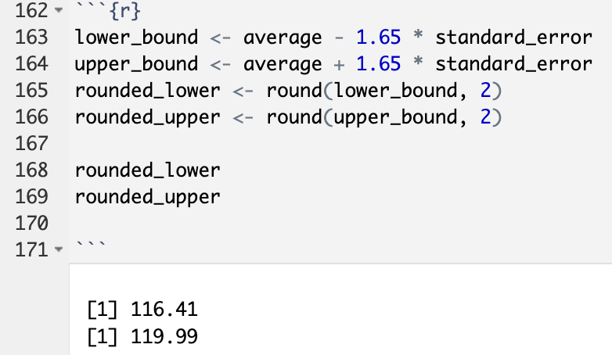  
  
 The 90% confidence interval is (116.41,119.99)

**C**.

Yes. We rejected the null hypothesis, Since the null hypothesis value of 100 is not within the confidence interval, the results of the hypothesis test are consistent with the confidence interval, both indicating the same conclusion.

**CLT.** Define the term “sampling distribution” of the mean, and describe how the shape, center, and spread of the sampling distribution of the mean change as sample size increases.

**ANSWER**

The sampling distribution represents the distribution of all possible sample proportions. According to the Central Limit Theorem, if the observations are independent and the sample size is large enough, the sampling distribution will take on a bell-shaped curve, centred around the true population proportion.

In short, A sampling distribution shows how n samples from a population are distributed. When the sample size n increases, the distribution gradually takes the shape of a normal distribution. As the sample size grows, the distribution becomes more focused around the center, with a tighter spread and more data points concentrated near the mean.

**CFLBs.** A manufacturer of compact fluorescent light bulbs advertises that the distribution of the lifespans of these light bulbs is nearly normal with a mean of 9,000 hours and a standard deviation of 1,000 hours.

1. What is the probability that a randomly chosen light bulb lasts more than 10,500 hours?
2. Describe the distribution of the mean lifespan of 15 light bulbs.
3. What is the probability that the mean lifespan of 15 randomly chosen light bulbs is more than 10,500 hours?
4. Sketch the two distributions (population and sampling) on the same scale.
5. Could you estimate the probabilities from parts (a) and (c) if the lifespans of light bulbs had a skewed distribution?

**ANSWER**

1. First, we need to find the z-score for this sample using the formula: z = (x - μ) / σ. After that, subtract the result from 1, because we're trying to find the probability of getting 10,500 or more.

z = (10500 - 9000)/1000 = 1.5, P(Z>1.5) = 1 - P(Z<1.5) = 1 - 0.9332 = 0.0668.

The chance that a randomly selected light bulb will last longer than 10,500 hours is 6.668%.

1. The average lifespan follows a normal distribution. The sample mean is 9000, with a sample standard deviation of 258.2, calculated as 1000 divided by the square root of 15.

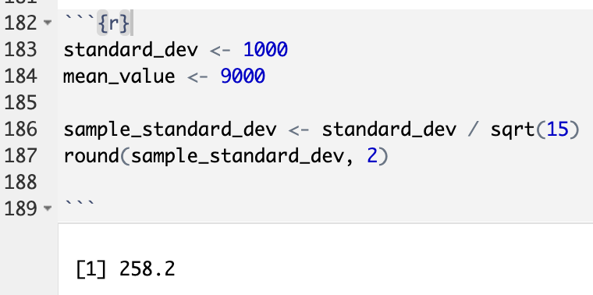

Distribution will be normal.

1. z = (10500 - 9000)/(1000/sqrt(15)) = 5.81, P ( Z > 5.81 ) = 1 – P ( Z < 5.81 ) = 1 - 1.000 = 0.

The probability shown below is extremely small, almost negligible. As a result, it is impossible for the mean lifespan of 15 randomly selected light bulbs to exceed 10,500 hours.

1. A screenshot of a computer

   Description automatically generated
2. No, the estimate needs a distribution with minimal skewness. We couldn't estimate part without having a distribution that is close to normal. If the light bulbs' lifespans followed a skewed distribution, we wouldn't be able to estimate the probabilities accurately. This is because one of the key assumptions in parts (a) and (c) is that the data is normally distributed.

**Same observation, different sample size.** Suppose you conduct a hypothesis test based on a sample where the sample size is n = 50, and arrive at a p-value of 0.08. You then refer back to your notes and discover that you made a careless mistake, the sample size should have been n = 500. Will your p-value increase, decrease, or stay the same? Explain.

**ANSWER**

The p-value is influenced by the z-value. Because the z-value calculation uses the standard error in the denominator, a larger sample size leads to a smaller standard error and a higher z-value. This, in turn, causes the p-value to decrease.

Based on normal probability, the test statistic increases as the sample size n increases. Since a larger test statistic leads to a smaller p-value, increasing n from 50 to 500 will result in a decrease in the p-value.